

Car Park Management System
Visitor Parking Request Guide
Estates Directorate
This document should be used when trying to create a request for a Visitor Permit for use on Queen’s University Belfast sites
11/11/2009

Table of Contents

Queen’s University Belfast Car Park Management System 3

Introduction 3

Access to the Visitor Car Parking System 4

To Register on the Car Parking System as a User 11

Login for Registered Users 15

To Create a Visitor Request 17

To Print an Existing permit 28

To Cancel a Visitor Car parking Request 32

User Feedback 35

Notes 36

Queen’s University Belfast Car Park Management System

Introduction

The Estates Directorate has introduced a new Car Park Management solution designed to enhance the user experience related to car parking on any of the University sites. It has been in operation for approximately one year with permits issued to staff from the system at the last two renewal periods. Staff who have existing permits have been able to renew their annual permit simply using the web page access provided.

Visitor parking at the University has been a source of concern for some time with difficulties being experienced by guests in locating a suitable parking bay, despite them having previously contacted staff to organise the visit. To alleviate these concerns a new method of booking visitors into a visitor parking bay on site has been added to the Car Park Management System. The process required to achieve the desired outcome has been modified, allowing all staff to determine if a space is available for the required date and time. This process is fully described in the following pages.

It should be noted that, following consultation, it has been decided that visitor parking will only be made available at a restricted number of sites. The visitor spaces available within each site will be clearly identified and should be used solely by visitors. Currently visitors can only be accommodated in the Main Site Car Park, Ashby Car Park, MBC Car Park and Institute of Clinical Sciences (Block B) Car Park.

Details of available visitor car park spaces can be seen at:

http://www.qub.ac.uk/visitorparking

Access to the Visitor Car Parking System

Access to the visitor section of the Car Park Management System is via the Queen’s On Line pages of the QUB web site as shown.

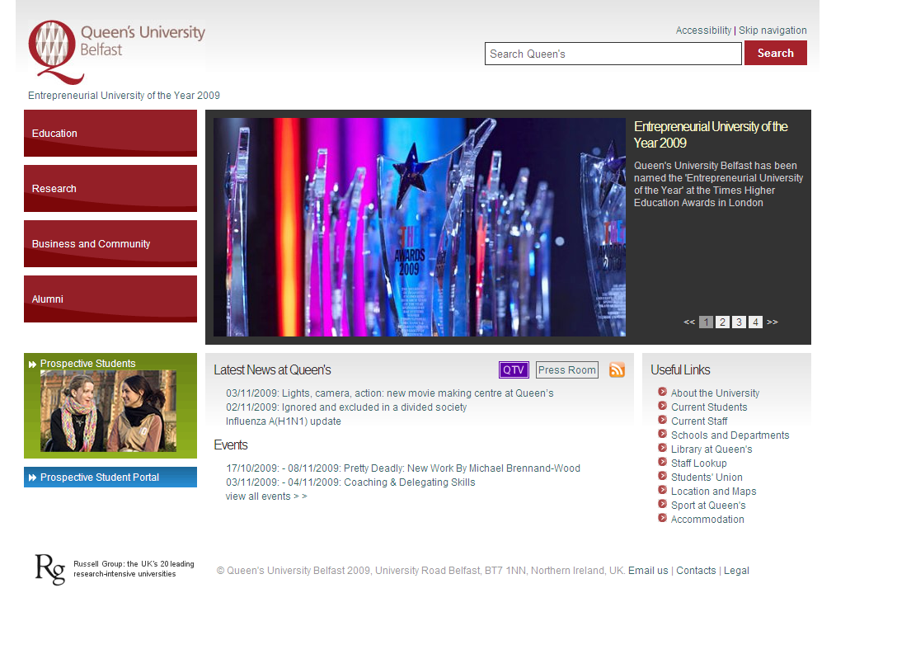

Select the Current Staff option as shown.

The user is now presented with the following screen.

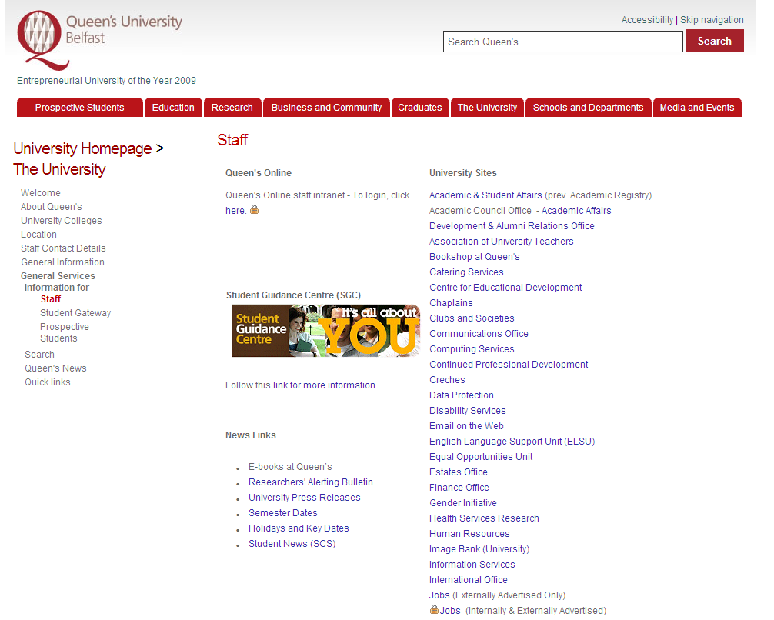

The users should now click on the hyperlink for access to the Queen’s Online staff intranet.

When the following screen is displayed the user should press the Login to Queen’s Online button.

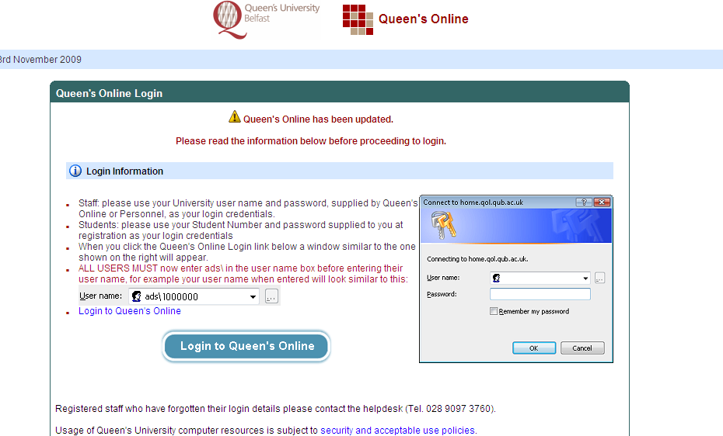

When this button is pressed the user will be expected to enter their user name and password for access to Queen’s Online.

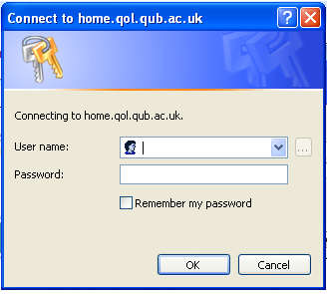
The user should enter the test “ads\XXXXXXX where XXXXXXX is their staff number.

Once this has been entered tab to the password field. Here the user should enter their Novel password.

The user has now accessed their privileges on the Queen’s Online intranet. Although all users are provided with different access rights the layout of the screen displayed should be similar to the following:-

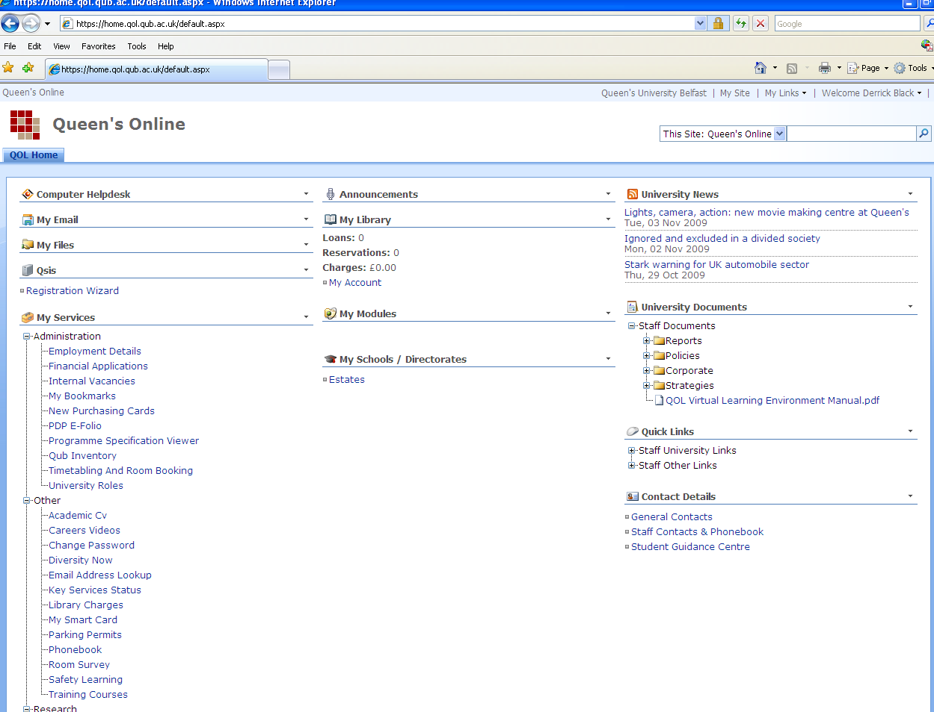
To access the Car Parking System users should choose the option Parking Permits.

This will display the screen shown below. Users should press the hyperlink indicated in blue.
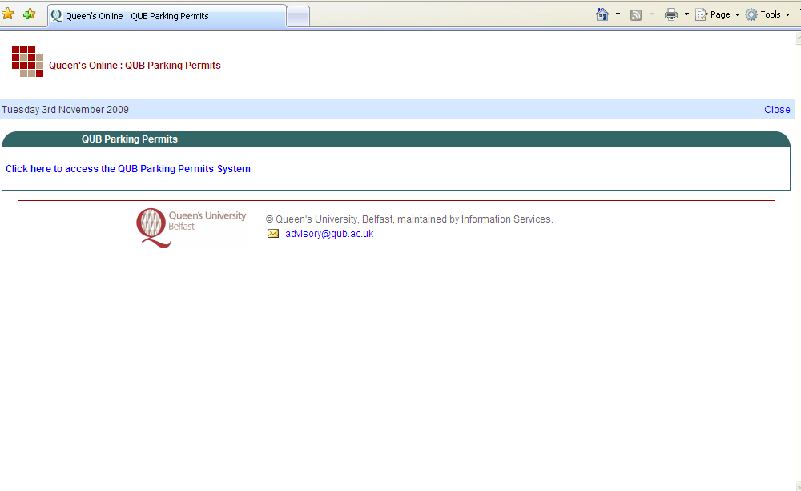

This will take the user to the Car Park Management System.

Access to the Car Park Management System is controlled by the use of a user name and password. This provides the necessary security for staff allowing them the ability to control their car park requests and vehicle details. Those members of staff who currently have an annual car parking permit will already have been sent a user name and password. However, those members of staff who do not currently have access to the system will be required to register on the system prior to using it.

If you do not have a current staff car park permit follow the instructions below to register.

If you have already registered, (this will include all current staff permit holders) please proceed to the Login for Registered Users on Page 15

To Register on the Car Parking System as a User

When you access the Car Park Management system the following screen will be displayed. Chose the option for new users by pressing the Start Here hyperlink.

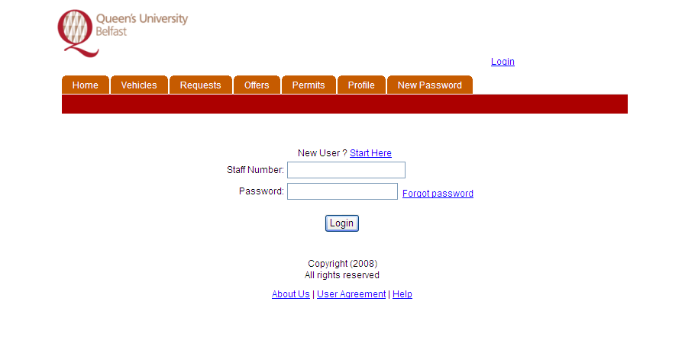

The following profile screen will be displayed

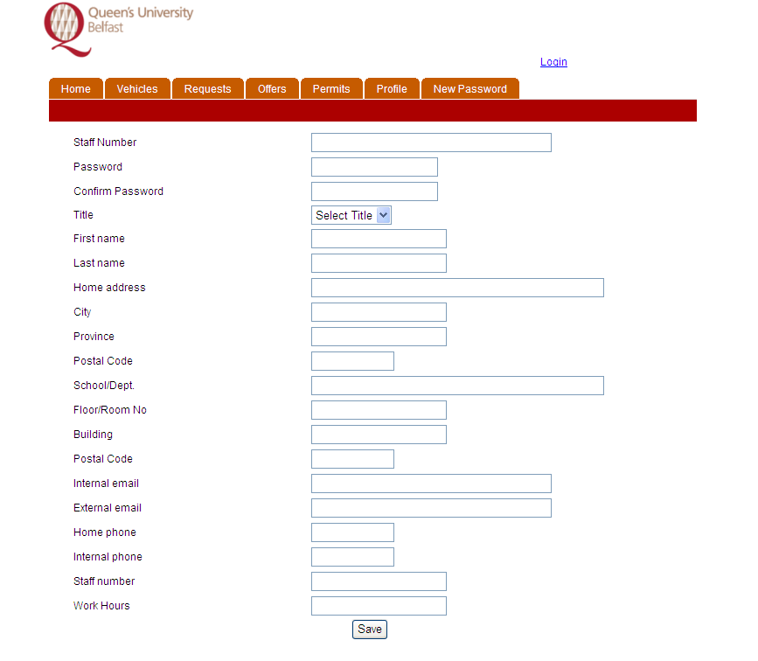
The user should complete the fields with their relevant details. Please note that not all fields are mandatory. However, the user must complete the following fields before the profile will be saved.

Staff Number

Password

Confirm Password

First Name

Last Name

School/Dept

Floor/Room No

Building

Postal code

External Email

Staff Number

If any of these fields are omitted the system will display an error message similar to the one shown.
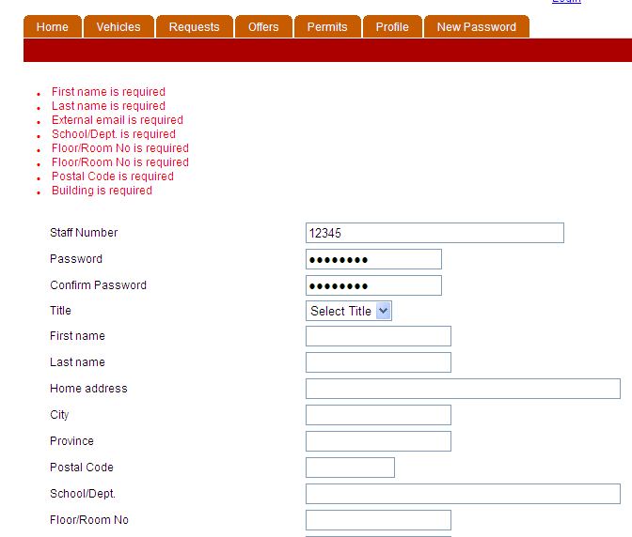

The same information must be typed in the password and confirm password fields.

The external email address field is mandatory. All users must provide an entry in the external email address as this is the email that will be used to communicate information regarding the Car Park Management system to all users. In the majority of instances the external email address should be completed with the Queen’s University Belfast email address provided to the user by Information Services. However, if a user wishes to provide an alternative external email address they may do so.

Please note that the external email address supplied as part of this profile must be unique. If a user attempts to enter a previously used external email address, such as another member of staff’s email address, this may cause a conflict. In this instance the system will refuse to save the user profile.

Once all the required fields have been completed the user should press the save button.

On successful completion of the profile the user will be presented with the following screen.

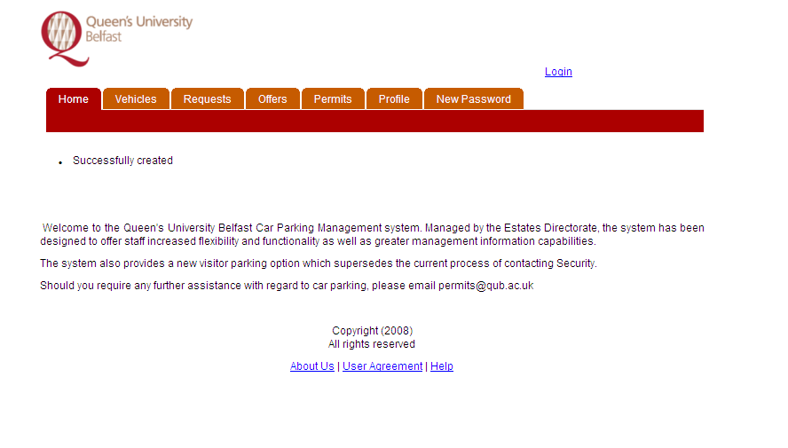
The user should now press the login option to display the login screen.

Login for Registered Users

Users should enter their user name and password in the appropriate fields

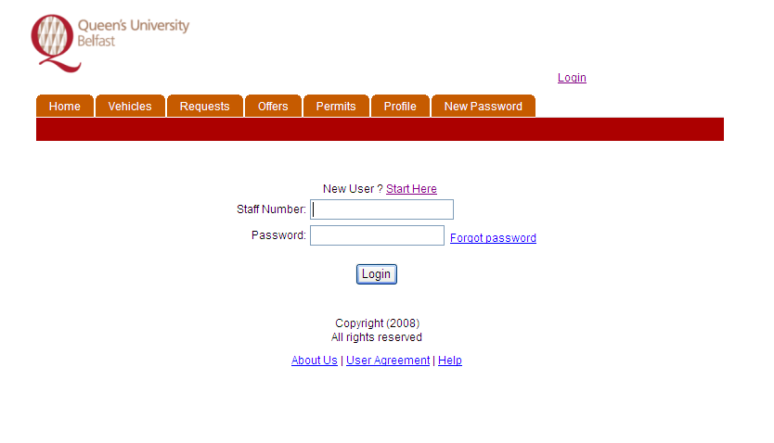

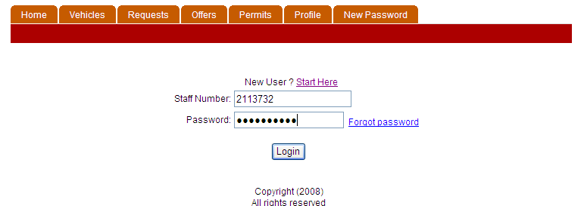
Press the Login button to enter the system. If the details are incorrect the user will be denied access and the following screen will be displayed
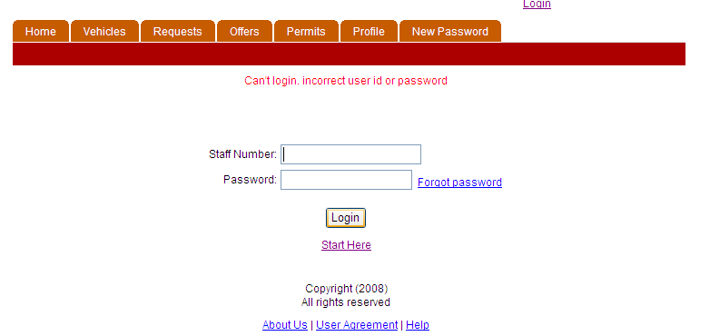

If this screen is displayed re-enter the correct details.

Once a user has been successfully logged onto the system the following screen will be visible.

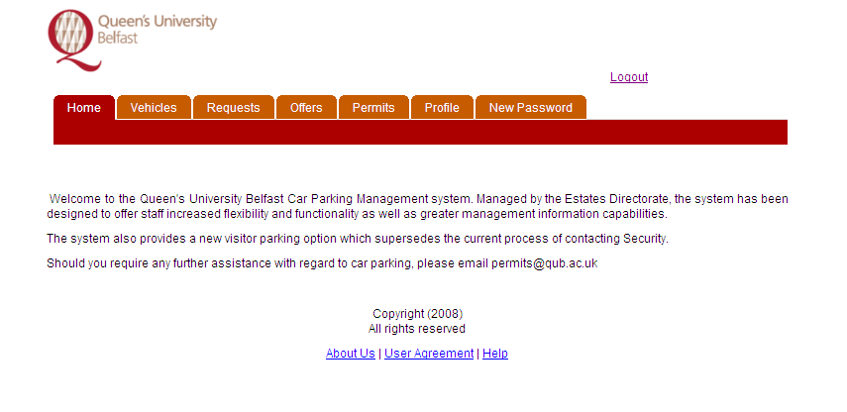

To Create a Visitor Request

A user can create a request for a visitor car parking space as follows.

Select the Request Tab as shown by pressing the tab once.
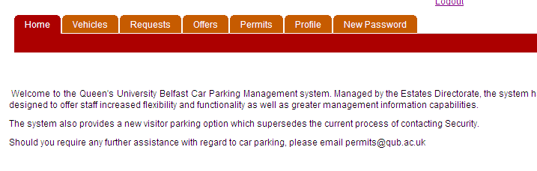

This will display the following web page.

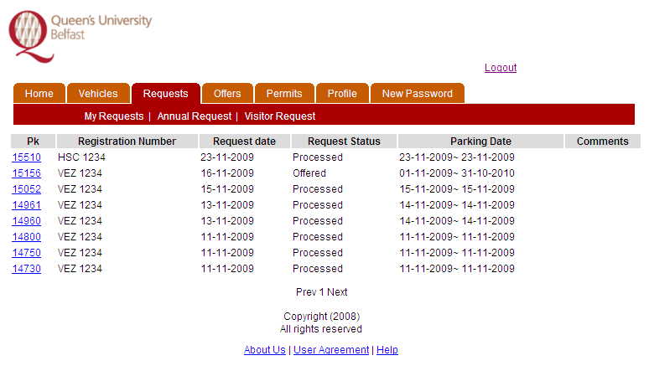
This screen shows any previous requests made by the user for permits.

Select the Visitor Request Option

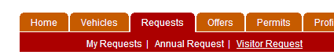

The web page will change to the following

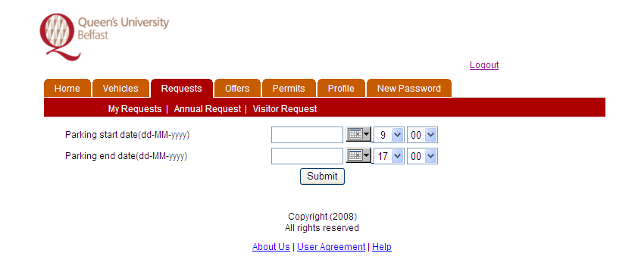
The user should now select the appropriate dates and times of the visit using the options provided.

The date is selected using the arrow on the right hand side of the calendar

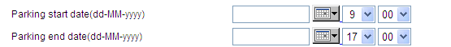

Pressing this arrow will present a calendar from which the user can select the required date.

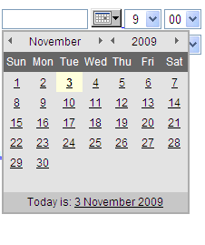
To select the date the user should click on the date using the left hand mouse button. The date can be changed by using the arrows at the top of the calendar, as shown.

To change the month, use the arrows on either side of the Month.

Using the arrow will choose the previous month while the arrow will select the next month. The year of the required date can be changed in a similar way.

The time of the visit is divided into hours and minutes. Each is operated by pressing the button on the right hand side of the field.
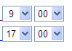
Choosing the hours option (located on the left hand side) will display the hour in a 24 hour clock style.

Select the required hour.

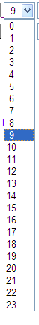
The minutes section is divided into half hour segments with only the option of 00 or 30. Choose the appropriate selection.
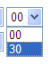

The combination of the hours and minutes section gives the arrival or departure time. Please note that both the start date and time and the end date and time must be completed correctly.

Having completed the required date and time fields the user should now press the submit button.
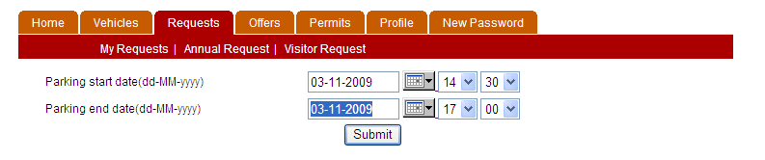
The user is now presented with a list of available spaces.

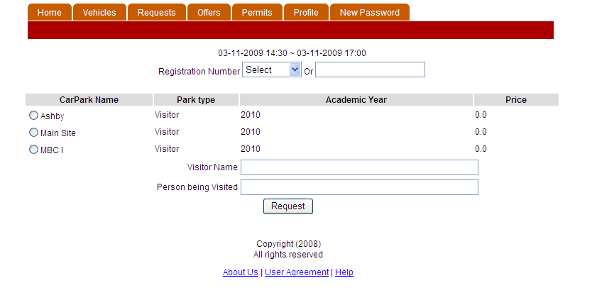
The user must complete the Registration field with an appropriate registration.

The system does not prohibit a user from booking themselves into a visitor car parking bay but this should only be done when the user is attending a meeting at a location other than their own and only when no alternative arrangements can be made.

If a user is booking themselves into a visitor space they can select their vehicle from the drop down list by using the arrow at the right hand side of the field.
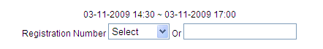

The user will be presented with the registration of those cars that they have registered in the system

Select the appropriate vehicle.
If the user is booking a visitor, not themselves, onto site they should complete the second Registration number field as shown

The details of the vehicle being used by the visitor should be entered here. If for some reason the number is unknown the user can enter the text “Hire Car”, although it is preferred that the correct registration number is entered where possible.

Having completed the vehicle information the user should now select the required Car Park.
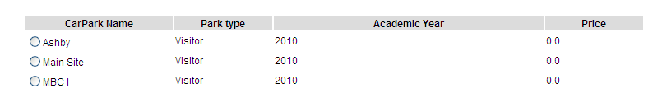

To do this a user should select the circle (or radio button) to the left of the required car park name. If no spaces are available for the time slot chosen in a particular car park the car park name will not be displayed. Only car parks with available spaces will be displayed on this list. No other visitor spaces will be provided if all visitor car parking bays are used. If none are available the user can re-request for a different timeslot if required.

Having selected the car park required the user should now complete the name of the person visiting and the name of the person being visited. These fields are mandatory and no space will be allocated until they have been completed.

The completed request should be as follows
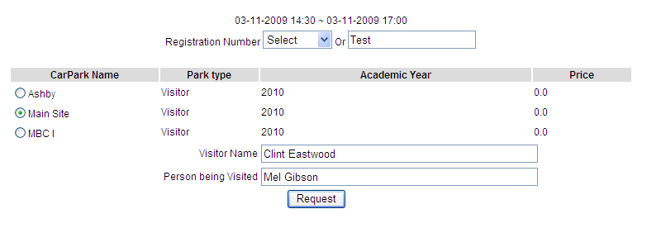At this stage the user should press the request button.

Having successfully added a request the user will be presented with the permit screen below

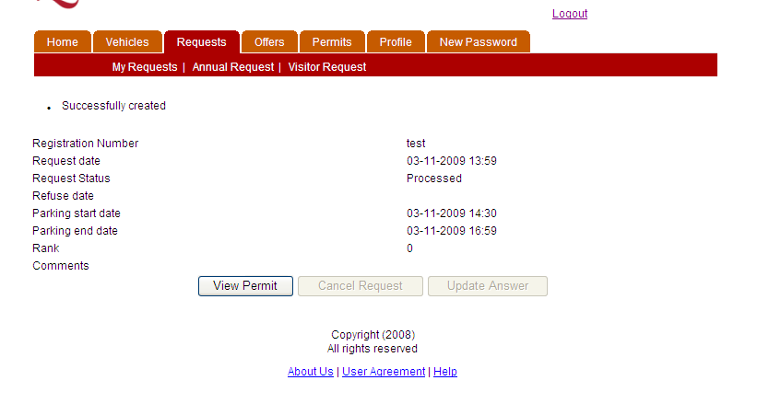
The user must now view the permit before leaving the request. Users have a responsibility to provide the permit to the visitor. This can be achieved either by printing the permit and handing it to the visitor prior to arrival or by emailing the permit to the visitor, again prior to arrival so that they can print the permit. The visitor must display a valid permit to allow entry to the University Car Park.

To view the permit prior to printing press the view permit button.

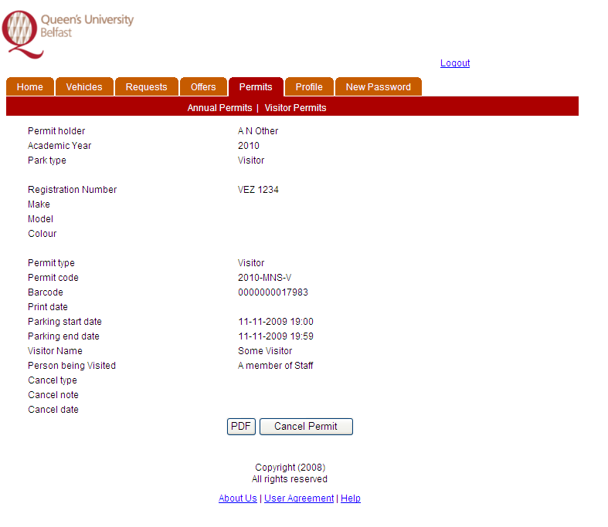

This screen gives details of the user who created the request, date and time of the visit, the name of the visitor and the person being visited etc. To print this permit press the PDF button.

The permit is displayed as shown.



VISITOR CAR PARK PERMIT

Car Park: Main Site Visitor

Registration: VEZ 1234

For: 3 Nov 14:00 – 3 Nov 16:59

Full details on visitor parking, including locations of visitor parking bays, are available at:

www.qub.ac.uk/visitorparking/

If you have any questions about your permit or its use please contact the Estates Directorate on
028 9097 5005.
----------------------------------------------------------Please fold here-------------------------------------------------------
Conditions of Use:

- This Visitor Permit is only valid for use on the dates and times within the car park indicated above.

- Please display this permit on the dashboard of your car.

- The penalty for failing to display a valid permit or failing to park in a designated visitor parking bay could result in the vehicle being immobilised with a release fee of £25.

- Please ensure that you only park in a designated visitor parking bay which are identified within the Main Site, MBC and Ashby car parks.

- Pedestrians have the right of way within Queen’s University property. The maximum permitted speed limit for all vehicles is 10 miles per hour.

- All vehicles brought onto University property should be adequately insured, as the University cannot be held responsible for any loss or damage which may occur.

To print the permit select the File option and chose Print

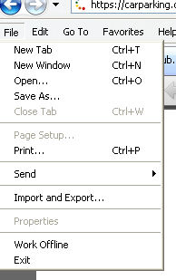
To email the permit choose the File option then Save as. Save the file to an appropriate place using the explorer screen as shown.

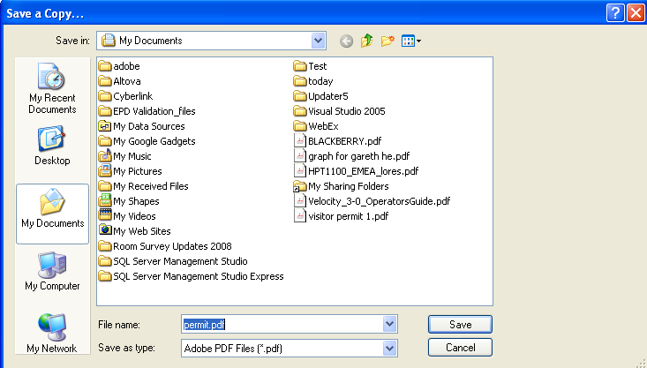

Once the file is saved it can be added to an email as an attachment as normal.

The visitor car park permit request is now complete. Close the print preview and logout out of the system unless you wish to make another booking. In this case use the back button on the web browser to return to the “create request option”.

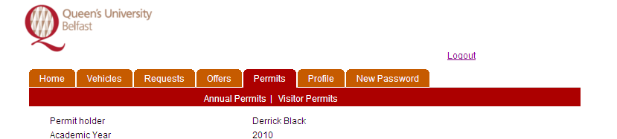

To Print an Existing permit

To print an existing permit the user should log onto the Car Park Management System.

Choose the Request Tab.

Select the My Request Tab.

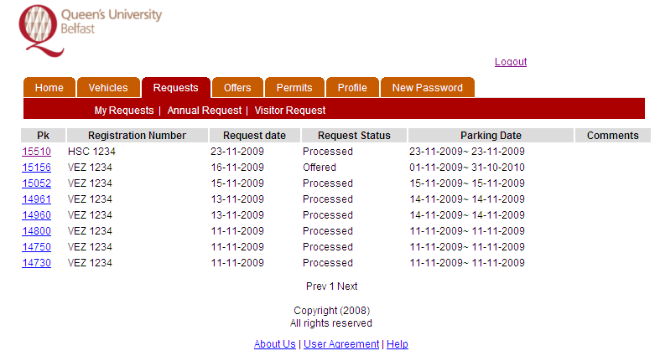

This presents a list of permit requests made by the user. They are in chronological order with the latest request displayed at the top of the list. The permit may be located by using the parking date or registration field. Once located press the hyperlink (indicated by the blue text) of the relevant permit request. In this example 15510 has been chosen.

Once selected the permit will be displayed
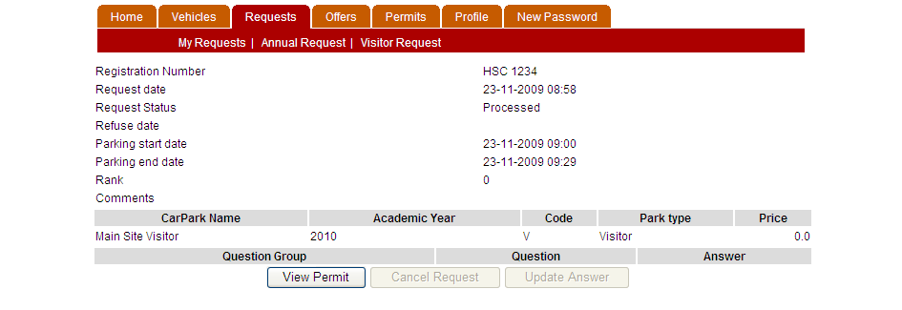

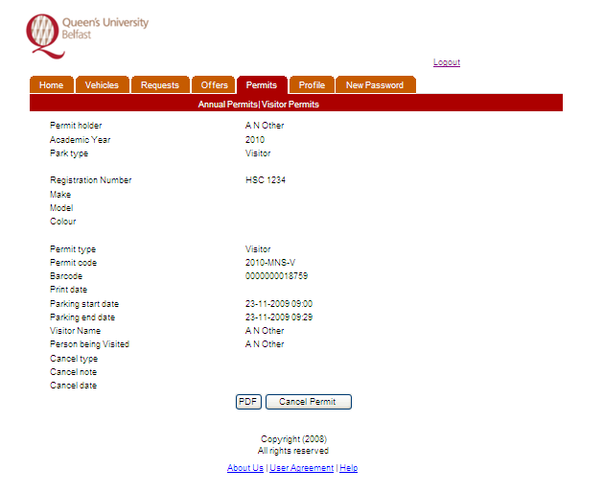
Choose the View Permit option

To print the permit, select the PDF option. The permit will be displayed

VISITOR CAR PARK PERMIT

Car Park: Main Site Visitor

Registration: HSC 1234

For: 23 Nov 14:00 – 23 Nov 16:59

Full details on visitor parking, including locations of visitor parking bays, are available at:

www.qub.ac.uk/visitorparking/

If you have any questions about your permit or its use please contact the Estates Directorate on
028 9097 5005.
----------------------------------------------------------Please fold here-------------------------------------------------------
Conditions of Use:

- This Visitor Permit is only valid for use on the dates and times within the car park indicated above.

- Please display this permit on the dashboard of your car.

- The penalty for failing to display a valid permit or failing to park in a designated visitor parking bay could result in the vehicle being immobilised with a release fee of £25.

- Please ensure that you only park in a designated visitor parking bay which are identified within the Main Site, MBC and Ashby car parks.

- Pedestrians have the right of way within Queen’s University property. The maximum permitted speed limit for all vehicles is 10 miles per hour.

- All vehicles brought onto University property should be adequately insured, as the University cannot be held responsible for any loss or damage which may occur.

To print the permit select the File option and choose Print

To Cancel a Visitor Car Parking Request

To cancel a request the user should log onto the Car Park Management System.

Choose the Request Tab.

Select the My Request Tab.

This presents a list of permit requests made by the user. They are in chronological order with the latest request displayed at the top of the list. The permit may be located by using the parking date or registration field. Once located press the hyperlink (indicated by the blue text) of the relevant permit request. In this example 15156 has been chosen.

Once selected the permit will be displayed

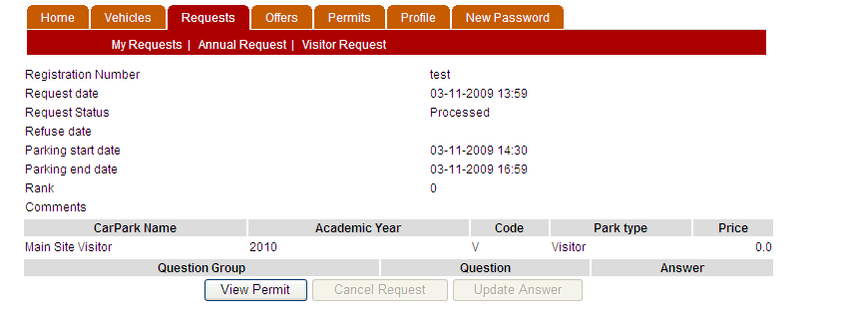
Choose the View Permit option
To cancel the permit, select the Cancel option. On successful cancellation the following screen will be displayed.
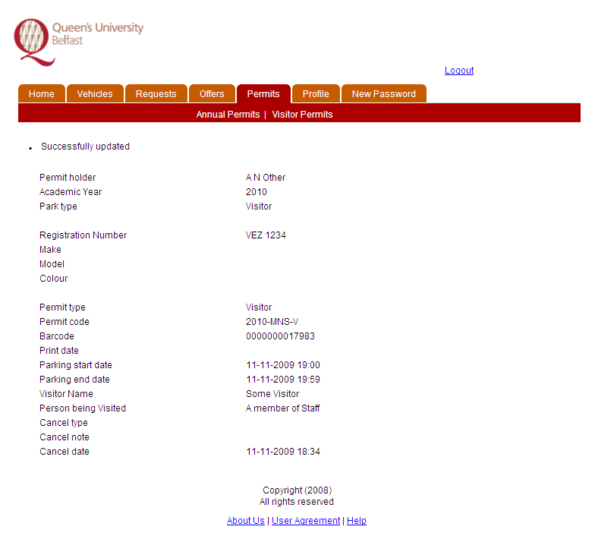

User Feedback

The Estates Directorate would welcome feedback from all staff on the operation of the system. Any suggestions will be considered and, where appropriate, included in the system to enhance the user experience of the solution.

To contact Estates on the use of the Visitor Car Parking System contact permits@qub.ac.uk

Notes

- Where reference is made to pressing a button on the computer screen this action is achieved using the left hand mouse button.

- Where reference is made to selecting a Tab in these notes this action is achieved by pressing the left hand mouse button

- It is assumed that the mouse being used is configured for right hand operation.

